Spotting Yellow Leaf Disease from Space: Satellite-Based Mapping and Early Detection of Arecanut YLD in Sringeri and Sulya Taluks, Karnataka
Names: Akash Gurusiddappa Bhagoji
Anmol Jain P
Gopal Krishna
Hemanth
Department of MCA, RV college of Engineering, Karnataka, India

Abstract-Yellow Leaf Disease (YLD), caused by phytoplasma, can cut arecanut yield by roughly half within three years of infection; a 2018 field survey in Sringeri and Koppa villages recorded incidence between 87% and 96%. Manual field surveys check only a handful of gardens per location, leaving wide-area monitoring gaps. This paper presents a satellite-based monitoring framework for Sringeri and Sulya taluks, Karnataka, built on free Sentinel-2 imagery (10 m resolution) collected monthly over three years for both taluks (72 taluk-month datasets), combined with KSNDMC rainfall/temperature records and KGIS boundary data. Fifteen vegetation indices covering greenness, chlorophyll, red-edge, and moisture-stress signals are computed in QGIS and reduced by correlation filtering and Random Forest feature importance to the 6-8 most discriminative indices. A Random Forest classifier trained on field GPS and Google Earth Pro reference points maps arecanut distribution and classifies gardens as Healthy, Stressed, or Suspected YLD, with results tracked monthly to reveal disease hotspots and spread. The system targets an overall accuracy of at least 85% and a Kappa coefficient of at least 0.80, validated against independent field points, with errors fed back to improve the mapping and diagnosis steps.
Index Terms-Arecanut, Yellow Leaf Disease, phytoplasma, Sentinel-2, remote sensing, vegetation indices, NDRE, red edge, Random Forest, precision agriculture.
I. Introduction
Yellow Leaf Disease (YLD) is a phytoplasma-induced disorder that ranks among the most damaging biotic threats to arecanut (Areca catechu) cultivation in Karnataka, capable of cutting yield by roughly 50% within three years of infection [1]. A 2018 field survey in Sringeri and Koppa villages recorded incidence between 87% and 96% [1], and the disease has continued to affect growers in the region in subsequent years [2], [4]. Ground-based scouting, the current standard for detection, checks only a handful of gardens per location and typically confirms disease only after visible canopy damage, by which point management options are limited.
Satellite remote sensing offers a scalable alternative: multispectral sensors can capture the subtle spectral shifts that precede visible symptoms, enabling wide-area, repeatable, and early monitoring. This paper describes a monitoring pipeline built entirely on free Sentinel-2 imagery and open tools (QGIS) that combines vegetation-index analysis with Random Forest classification to map arecanut cover and flag suspected YLD across Sringeri and Sulya taluks over a three-year period.
II. Study Area and Data
The study covers Sringeri and Sulya (Sullia) taluks, Karnataka, both historically high-incidence regions for YLD [1], [4]. The primary data source is Sentinel-2 Level-2A surface-reflectance imagery, acquired monthly over a three-year window for both taluks, yielding 72 taluk-month datasets (3 years × 12 months × 2 taluks) at 10 m pixel size, obtained through the Copernicus Browser. Rainfall and temperature records from the Karnataka State Natural Disaster Monitoring Centre (KSNDMC) are used to separate weather-driven stress from disease-driven stress, and KGIS boundary layers together with Google Earth Pro reference imagery define taluk and garden extents.
III. Six-Step Methodology
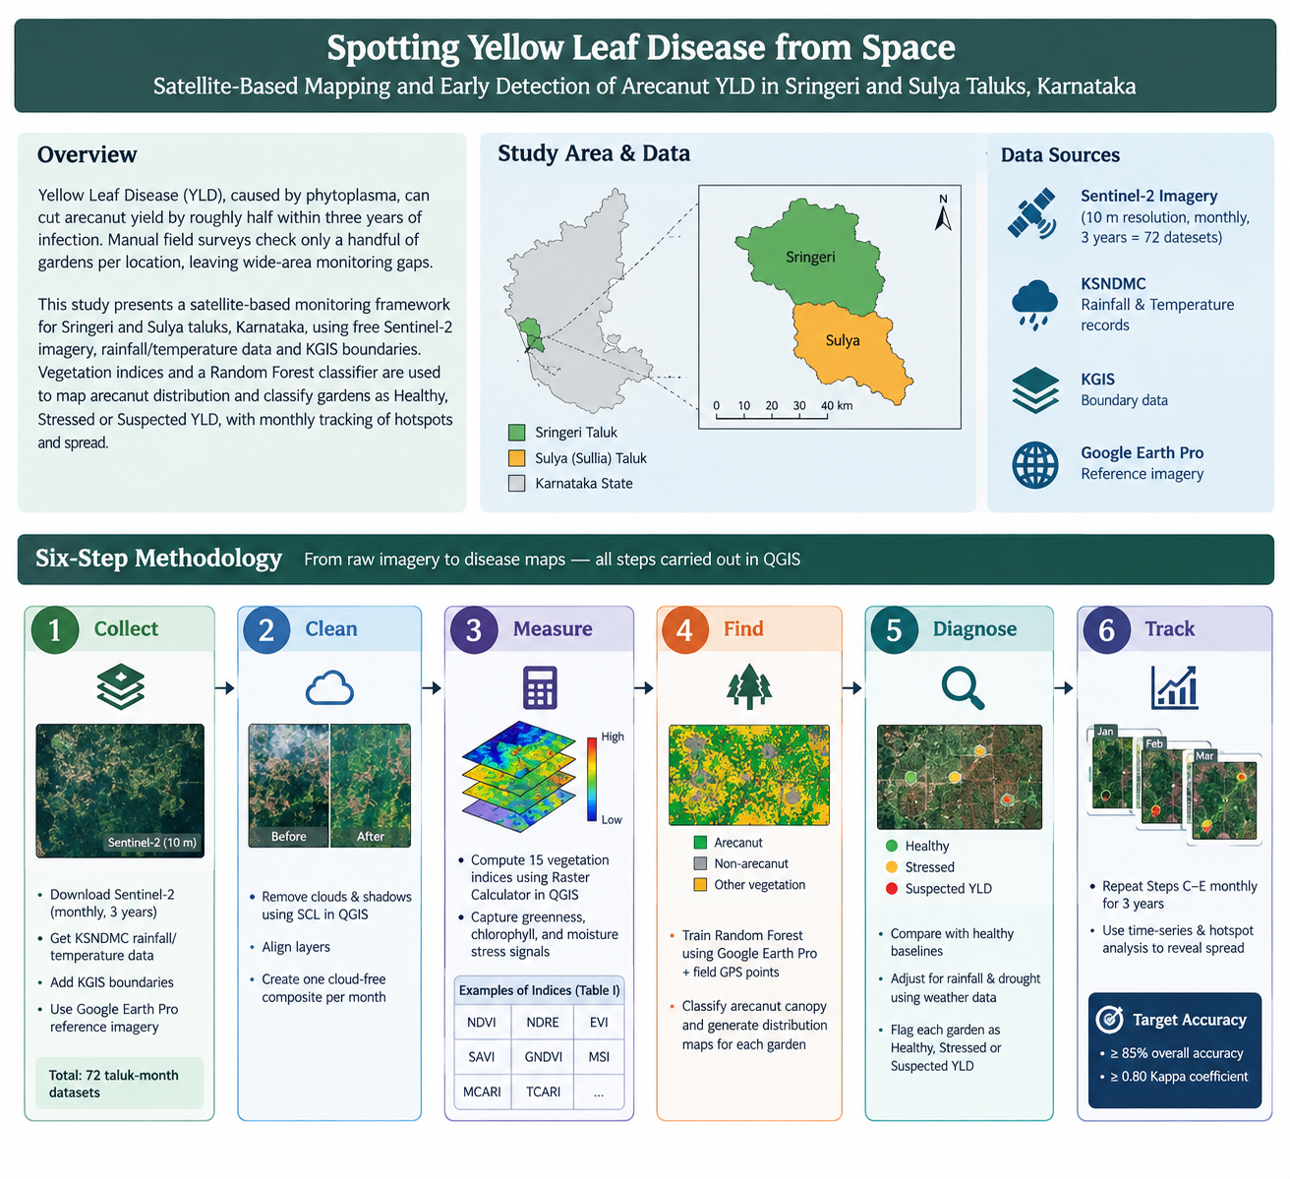

The pipeline moves from raw imagery to disease maps in six steps, carried out largely in QGIS.
A. Collect. Free Sentinel-2 imagery for both taluks is gathered every month for three years via the Copernicus Browser, together with KSNDMC rainfall/temperature records, KGIS boundaries, and Google Earth Pro reference imagery, producing 72 taluk-month datasets.
B. Clean. Clouds and shadows are removed using the Scene Classification Layer (SCL) in QGIS, layers are aligned, and each month is blended into one cloud-free composite image.
C. Measure. Fifteen vegetation indices are computed with the QGIS Raster Calculator, converting spectral colour into numbers that describe greenness, chlorophyll status, and water stress for every monthly composite (Table I).
D. Find. A Random Forest classifier, trained on Google Earth Pro and field GPS points, recognises arecanut canopy and produces a distribution map for every garden across both taluks.
E. Diagnose. Each garden is compared against healthy baselines, adjusted for rainfall and drought using weather data, and flagged as Healthy, Stressed, or Suspected YLD.
F. Track. Steps C–E are repeated every month across the three-year record to reveal where the disease appears and how fast it spreads, via time-series and hotspot analysis.
Every step is checked against field GPS points and Google Earth Pro references, against targets of overall accuracy ≥ 85% and Kappa ≥ 0.80; errors identified during validation are fed back to refine Steps D and E.
IV. The 15 Vegetation Indices
Table I lists the 15 candidate indices across four functional groups: greenness/biomass, chlorophyll/red-edge, yellowing/water-stress, and land-cover masking. Red-edge indices (NDRE, CIre, MTCI, IRECI) and PSRI react to chlorophyll loss earlier than NDVI and are therefore central to early YLD detection, while NDMI and MSI help separate drought stress from disease. NDVI, RVI, SAVI, and EVI serve as baseline greenness comparisons.
Feature selection follows a four-step funnel: (1) compute all 15 indices for every monthly taluk composite; (2) drop near-duplicate indices with pairwise correlation above 0.90; (3) rank the remaining features by Random Forest importance and healthy-vs-YLD class separability; and (4) retain the top 6–8 indices for the final classifier. The data — not assumption — determines the final feature set.

TABLE I. THE 15 VEGETATION INDICES
Domain | Index | Formula | What it tells us
Greenness & Biomass | NDVI | (B8−B4)/(B8+B4) | How green and dense the canopy is
 | RVI | B8/B4 | Leaf biomass
 | SAVI | 1.5(B8−B4)/(B8+B4+0.5) | Greenness with bare-soil glare removed
 | EVI | 2.5(B8−B4)/(B8+6B4−7.5B2+1) | Greenness that resists saturation in thick canopy
Chlorophyll & Red Edge | GNDVI | (B8−B3)/(B8+B3) | Early hint of falling chlorophyll
 | NDRE | (B8A−B5)/(B8A+B5) | Core early alarm for chlorophyll loss
 | CIre | (B7/B5)−1 | Total chlorophyll in the canopy
 | MTCI | (B6−B5)/(B5−B4) | Chlorophyll from red-edge position
 | IRECI | (B7−B4)/(B5/B6) | Chlorophyll and leaf area, dense canopy
Yellowing & Water Stress | PSRI | (B4−B2)/B6 | Whether the canopy is turning yellow
 | NDMI | (B8A−B11)/(B8A+B11) | Separates drought thirst from disease
 | MSI | B11/B8 | Water-stress level (higher = drier)
Land-Cover Masking | NDWI | (B3−B8)/(B3+B8) | Locates open water
 | NDBI | (B11−B8)/(B11+B8) | Locates buildings/settlements
 | BSI | ((B11+B4)−(B8+B2))/((B11+B4)+(B8+B2)) | Locates bare or fallow land
V. Known Challenges and Mitigation
Table II summarises the main technical difficulties identified for the pipeline and how each is addressed.
TABLE II. KNOWN CHALLENGES AND MITIGATION
Challenge | Mitigation
Monsoon clouds hide the ground (Jun–Sep) | Monthly cloud-free composites with gap-filling across neighbouring months; Sentinel-1 radar as optional back-up.
Drought/nutrient shortage also yellows leaves | NDMI and MSI moisture indices plus KSNDMC rainfall/temperature normalisation isolate disease-linked change.
A 10 m pixel is larger than one palm | Plot-level condition is mapped, verified with Google Earth Pro and GPS field points, and reported as “Suspected YLD,” not a diagnosis.
Coconut, banana, and pepper grow among arecanut | Random Forest is trained on field-verified samples and learns each crop's month-by-month behaviour.
≥ 10 m tree-height rule cannot be measured by Sentinel-2 | Applied as a mature-stand mask built from field and reference data.
VI. Work Plan and Validation
The 16-week internship (September–December) is organised into four monthly phases, each ending in a concrete milestone (Table III).
Accuracy is checked throughout using independent field GPS points and Google Earth Pro references, via confusion-matrix, overall-accuracy, Kappa, and F1-score evaluation, with expert review of suspected-YLD gardens. Targets are an overall accuracy (OA) ≥ 85% and a Kappa coefficient (κ) ≥ 0.80.
TABLE III. WORK PLAN (SEP–DEC)
Phase | Key Activities | Milestone
Sep – Learn & collect | Literature review; download 3 years of Sentinel-2 and KSNDMC weather; collect KGIS boundaries; plan field visits. | Data ready
Oct – Clean & measure | Cloud masking and monthly composites; compute the 15 indices; select the best 6–8 features. | Index stack ready
Nov – Map & diagnose | Arecanut mapping (Random Forest); health and YLD classification; field and Google Earth checks. | Arecanut & YLD maps
Dec – Track & deliver | Multi-temporal and hotspot analysis; accuracy assessment; final report and GIS datasets. | Final report

VII. Deliverables and Stakeholders
The project produces four outputs, each aimed at a different set of users (Table IV).
TABLE IV. DELIVERABLES AND STAKEHOLDER BENEFIT
Deliverable | Stakeholder | Benefit
Arecanut distribution maps | Growers | Early warning, so action starts before yield falls
Health & YLD severity maps | Extension officers | Target field visits and advice where stress is rising
Multi-temporal trend report | Researchers | Spread and hotspot data for disease-management studies
GIS-ready datasets (GeoTIFF/GeoPackage) | Planners | Area-wise evidence for support and management planning
VIII. Conclusion
This paper outlines a satellite-based framework for wide-area, early detection of Yellow Leaf Disease in arecanut, built on free Sentinel-2 time series, red-edge-sensitive vegetation indices, and Random Forest classification. By combining multi-temporal spectral analysis with weather normalisation, the framework is designed to flag suspected disease zones well before visible canopy damage, giving growers, extension officers, researchers, and planners spatially explicit, monthly-updated evidence at a scale manual field surveys cannot reach.
References
[1] Yellow Leaf Disease incidence survey, Sringeri and Koppa villages, Karnataka, Sept. 2018.
[2] Deccan Chronicle, news report on Yellow Leaf Disease impact on arecanut cultivation in Karnataka, Oct. 2021.
[3] Article on Yellow Leaf Disease symptoms and yield-loss assessment in arecanut, U.S. National Library of Medicine, PubMed Central, PMC8551408.
[4] Yellow Leaf Disease survey, Chikkamagaluru taluks, Karnataka, 2021–2022.
[5] European Space Agency, “Sentinel-2 User Handbook,” ESA Standard Document, 2015.
[6] L. Breiman, “Random forests,” Mach. Learn., vol. 45, no. 1, pp. 5–32, 2001.
[7] A. A. Gitelson, Y. Gritz, and M. N. Merzlyak, “Relationships between leaf chlorophyll content and spectral reflectance and algorithms for non-destructive chlorophyll assessment in higher plant leaves,” J. Plant Physiol., vol. 160, no. 3, pp. 271–282, 2003.
[8] J. W. Rouse, R. H. Haas, J. A. Schell, and D. W. Deering, “Monitoring vegetation systems in the Great Plains with ERTS,” in Proc. 3rd ERTS Symp., NASA SP-351, 1974, pp. 309–317.

